**A drawing of a cartoon character

Description generated with high confidence**

**Launch of the Africa Network on Corporate Governance of State-Owned Enterprise**

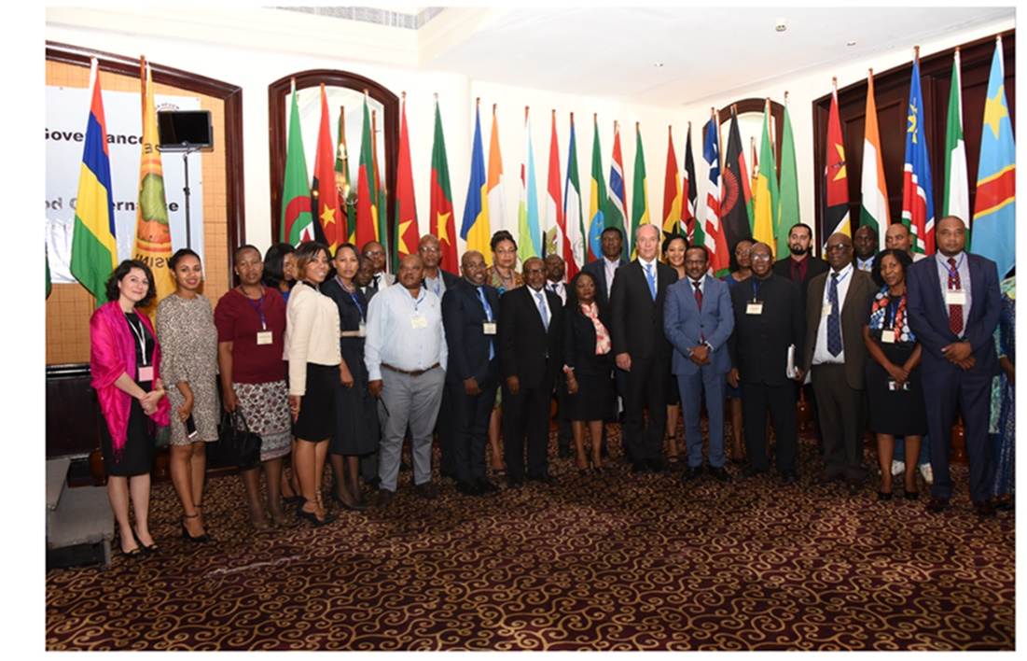

**Mauritius, 8 November** - The Africa Network on Corporate Governance of State-Owned Enterprises was officially launched in Mauritius on the 8th November 2018. The Network that was founded and managed by the OECD for the benefit of SADC countries, is now launched under the leadership of the APRM. The APRM took the leadership in view of advancing the Network's priorities which are aligned with the objectives of APRM to promote good corporate governance on the continent.

The launch meeting was opened by Ms. Tumi Dlamini, Lead Convener, African SOE Network, APRM. Followed by a remark by Ambassador Ombeni Sefue, APRM Lead Panel Member for Mauritius, Abdoulie Janneh, Mo-Ibrahim Foundation, Hon Leon Jooste, Minister of Public Enterprise, Namibia and Keynote Address by Hon Dharmendar Sesungkur, Minister of Financial Services and Good Governance, Mauritius. The launch was attended by representatives from 19 countries, including, Angola, Botswana, Chad, Congo Brazzaville, Congo DRC, Kenya, Lesotho, Mauritania, Mauritius, Namibia, Niger, Senegal, Seychelles, South Africa, Sudan, Swaziland, Zambia Zimbabwe and Turkey. Furthermore, Development Financial institutions namely DBSA, Afrexim Bank, the World Bank were represented in the launch meeting. APRM strategic partners, ACBF and Mo-Ibrahim Foundation also participated in the launch meeting. The OECD, represented by Ms. Sara Sultan, will remain the technical partner of the African SOEs Network.

The vision of the African SOEs Network is the full actualisation of the principles of good corporate governance in SOEs throughout the continent so as to ensure that SOEs operate on the same principles as comparable to private enterprises without at the same time losing the developmental goal for which they were established in the first place. The network aims to achieve this through exchange of best practices and peer learning.

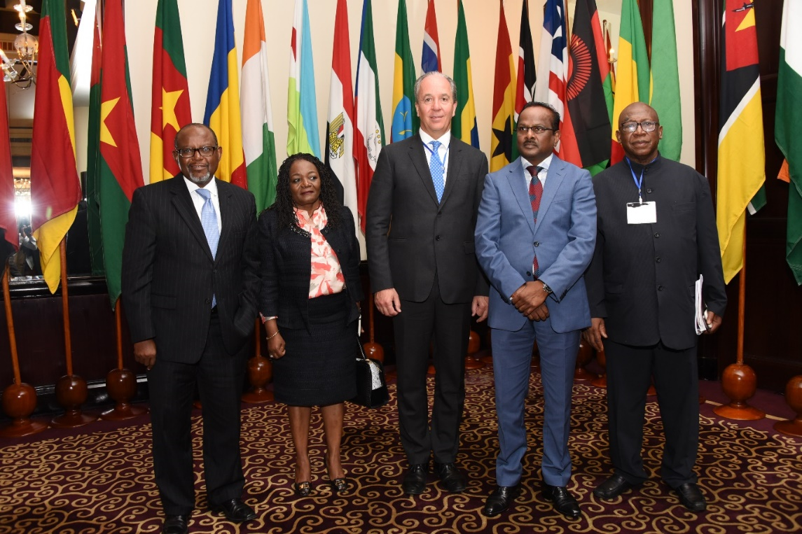

In his welcome remarks, Hon Dharmendar Sesungkur, Minister of Financial Services and Good Governance, Mauritius, mentioned that there is increasing evidence that better governance of SOEs is central to the development of successful nations. SOEs are being used more than ever as agents of developmental strategies as they are key drivers of social and economic prosperity and they help sustain political stability. He stressed that economic prosperity is to a large extent, dependent on the capacity of SOEs which are present across key sectors from infrastructure, transport, electricity, water supply, broadcasting, banking, insurance to telecommunications. Tolerating inefficiencies within these SOEs has today become too high a price to pay for any government to take a laid-back attitude on the matter.

The meeting will continue for the next two days and delegates are expected to present recent and planned SOE reforms; challenges in SOE governance reform related to corporate governance, accountability, transparency and disclosure, the developmental role of the state. Furthermore, the meeting will debate maintaining delicate balance between the developmental and profit generation role of SOEs.